BRITISH VALUES STATEMENT

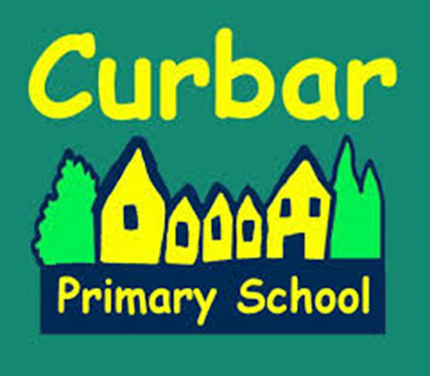

Reviewed/Adopted: June 2016
Next Review Date: June 2019
Review Frequency: Every three years
Reviewed By: Standards and Curriculum

British Values Statement for Curbar Primary School

The DfE have reinforced the need ‘to create and enforce a clear and rigorous expectation on all schools to promote the fundamental British values of democracy, the rule of law, individual liberty and mutual respect and tolerance of those with different faiths and beliefs.’

The Government set out its definition of British values in the 2011 Prevent Strategy, and these values have been reiterated recently. At Curbar Primary School, these values are taught through our broad, balanced and enriched curriculum. Frequent opportunities are provided so that our pupils can apply the key learning behaviours that; promote their spiritual, moral, social and cultural development; and support the school's vision to create valued members of our local and national community.

At Curbar Primary School we will actively challenge pupils, staff or parents expressing opinions contrary to fundamental British Values, including 'extremist' views. British Values is an ongoing theme within our whole school assemblies. The citizenship award is geared around the qualities that we believe make a good citizen.

Democracy

Pupil voice is used as a tool for school improvement. The Shine Assembly is an example of pupil's success and achievements in terms of learning behaviours and attitudes.

Parents complete a range of questionnaires as part of our ongoing consultation process. These comments are used to improve the school.

Pupil questionnaires have been used by subject leaders to prioritise actions and to evaluate the success/impact of change.

The Pupil Parliament plays an active part of the decision making process at Curbar Primary School. Members are voted for by their class and they regularly feature as a part of the whole school decision making process, taking and sharing information from their weekly meetings and then presenting back their findings in order that opinion can be sought.

The Rule of Law

A consistently applied Behaviour Policy is shared with the children (due to be updated September 2016). ‘The Curbar Code’ is reinforced regularly and opportunities are sought frequently to praise positive choices, through the use of behaviour tickets. Pupils' modelling behaviour consistent with the school's high expectations are recognised and used as role models to others. Our prefect system in year 6 is a point in case.

Through assemblies and the school's curriculum, children develop an understanding of law appropriate to their age. Access to high quality text gives pupils a safe way of exploring the 'breaking' of laws and an opportunity to discuss consequences when this occurs. Pupils are taught explicitly that laws keep us safe and our curriculum enables pupils the opportunity to recognise when they do and do not feel safe e.g. Safer Internet Day.

Visits from other external agencies such as the fire service, health professionals and 'People who help us' reinforces their understanding of the responsibilities held by various professions.

Individual Liberty

Protective Behaviours are taught across the school and every child is aware that they have the right to feel safe. They are also taught that there is nothing too awful that they cannot talk to an adult about.

Children are valued for their differences and there is a wide variety of extra-curricular clubs to enable children to try new things, develop new skills and practise existing ones. Care is taken to provide equal opportunities for all genders such as boys and girls and mixed sports teams.

Time and care is taken to know each child as an individual and regular circle time/citizenship sessions give children a chance to share their feelings and options in a safe way.

Opportunities for children to take on more responsibility within the school is encouraged. For example, the prefects are offered a range of opportunities over the course of a typical school year.

Mutual Respect

The schools use philosophy for children (P4C), as a vehicle to discuss and consider issues that may cause concern. The children are shown how to discuss and value the opinions of others.

If pupils show disrespect to one another, this is dealt with immediately through our behaviour policy and Parents/Carers are contacted.

An Anti-Bullying week is held annually and various well-being events are held across the year. During these sessions, children are taught to value differences in others and themselves and to respect others.

Many children at Curbar Primary School participate in local sports events and competitions both within our cluster and at a community level. These ensure children experience competitive events and have an opportunity to apply their sportsmanship skills with other schools.

Tolerance of those of Different Faiths and Beliefs

The school follows the agreed Derbyshire Religious Education (RE) syllabus which ensures that the children learn about all the religions of the world. Assemblies contribute to the knowledge of special occasions and children and their families come to share with the school information about how they celebrate these events at home. The local Reverend visits the school for community performances and talks to the children in assemblies; these talks coincide with main events occurring in the Christian calendar such as advent and Easter ensuring the focus of our collective worship is broadly Christian in character.

Resources in classrooms are regularly audited to ensure that they reflect our multicultural society and stereotypes are challenged.

In Conclusion

Part of our vision at Curbar Primary School is to prepare the children of the future to become valued members of society. Promoting British Values enables children to develop a sense of community and begin to understand their responsibilities and role within it.

A child friendly version of these laws has been put together by the Pupil Parliament.

- We know that we are special

- We treat everyone equally

- We understand right from wrong

- We understand the consequences of our actions

- We listen to and respect other people’s opinions and values

- We try to help other people

- We understand and respect the roles of people who might help us

- We respect the cultures and beliefs of others

See ‘Promoting fundamental British values as part of SMSC in schools’
Departmental advice for maintained schools – November 2014

See ‘Prevent Strategy – June 2011

