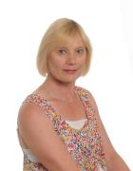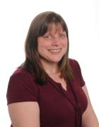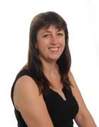

**Staff at Curbar Primary School 2015 - 16**

Mrs Berry will be your first teacher. She is also the Senior Teacher and teaches Class 1. She is the school SENCo

Miss Pattison teaches children in Years 3 and 4 (Class 2). She is the deputy designated safeguarding lead in school

Miss Gregory teaches the children in Years 5 and 6 (Class 3).

Mr Beahan is the Head teacher. He also teaches Class 3 for some of the week. He is the designated safeguarding lead in school

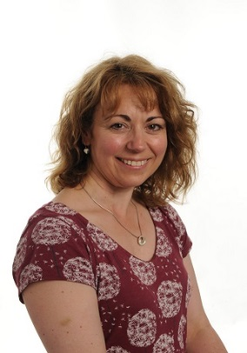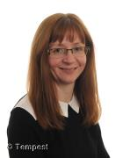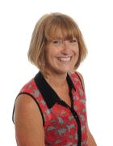

Mrs Sargen is a teaching assistant and is a playground supervisor at lunchtime.

Mrs Ridgeway is a teaching assistant and is a playground supervisor at lunchtime.

Mrs Patterson is a teaching assistant and she will work with you in the classroom.

Mrs Rumney works in the office. She will help you with your letters and dinner money.

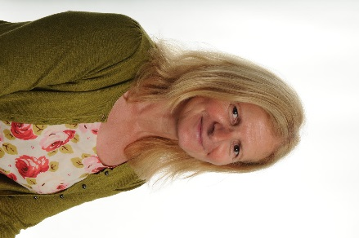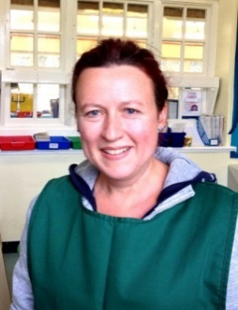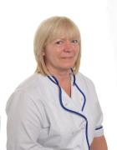

Miss Thompson works in the kitchen, helping to get your yummy dinners ready.

Mrs Wilson is the cook and cleaner. She keeps school clean and makes yummy dinners.

Mrs Cain is a midday supervisor and will help you at lunchtime.

Mrs Allen is a teaching assistant and is a playground supervisor at lunchtime.