Name: …………………………………………………………………………………………….………………..

Address: …………………………………………………………………………………………………………..

Home telephone number: …………………….…………….. Mobile: ………………………..………………

Email .........................................................................................................................................................

Number of pieces you wish to exhibit (max 6 *): …………………..

|  |  |  |
| --- | --- | --- |
| Title of piece | Medium | Price |
|  |  |  |
|  |  |  |
|  |  |  |
|  |  |  |
|  |  |  |
|  |  |  |

* Please note painters and photographers that you have an exhibition space of 6’ high by 4’ wide. There may be extra space but we cannot guarantee this.

Please return your completed form to The Curbar Art Show, c/o “Ingledew’, Hall Fold, Calver, Derbyshire, S32 3xl , by 6th April 2018 with a cheque for £8 made payable to “Curbar Primary School PTFA”.

Artist’s Signature: ……………………………………………………………………………..

This form must be returned to Ros Reader, 45 Smithy Knoll Road, Calver, S32 ??? by Friday 9th March 2007 with a cheque for £3 made payable to ????. Places are limited.

Application To Exhibit

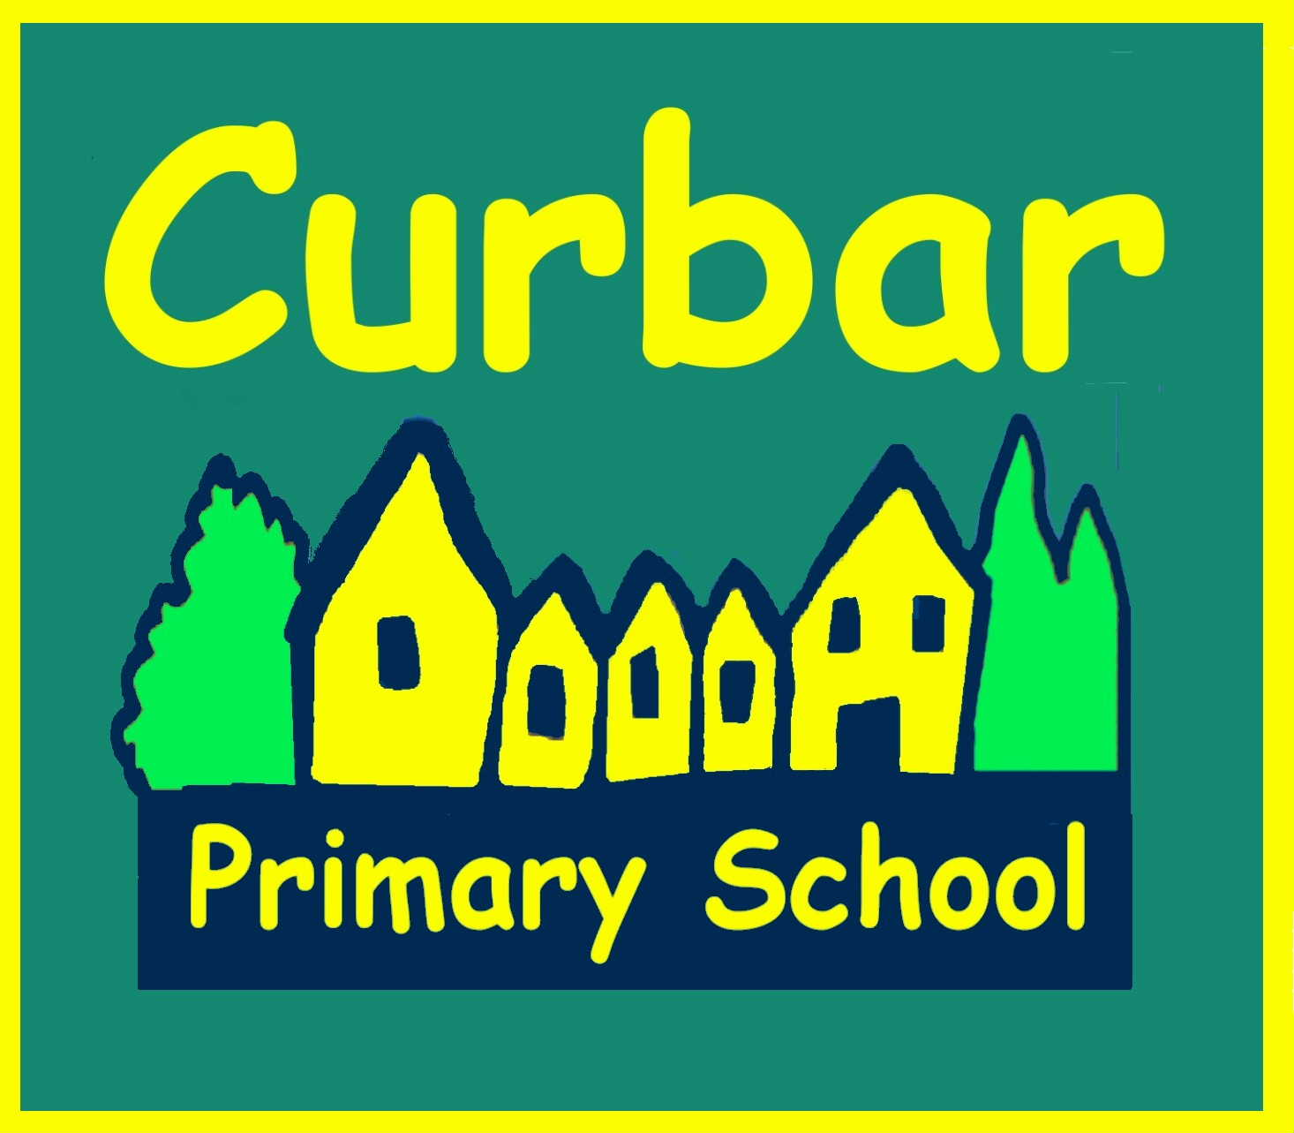

All monies made from The Curbar Art Show will go to Curbar Primary School to further improve the facilities and equipment for use by our children. This is an excellent local primary school which was judged as Outstanding in its Ofsted inspection. Thank you for your help in supporting our school.

MCj03086140000[1]

**The Curbar Art Show 2018**

Contemporary and Fine Art