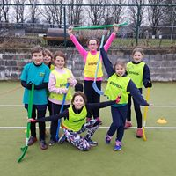
CURBAR PRIMARY SCHOOL

EVIDENCING THE IMAPCT OF PRIMARY PE AND SPORT PREMIUM FUNDING – JANUARY 2018

Schools must use the funding to make additional and sustainable improvements to the quality of PE and sport they offer. This means that you should use the Primary PE and Sport Premium to:

- develop or add to the PE and sport activities that your school already offers
- build capacity and capability within the school to ensure that improvements made now will benefit pupils joining the school in future years
There are 5 key indicators that schools should expect to see improvement across:
- the engagement of all pupils in regular physical activity - the Chief Medical Officer guidelines recommend that all children and young people aged 5 to 18 engage in at least 60 minutes of physical activity a day, of which 30 minutes should be in school
- the profile of PE and sport is raised across the school as a tool for whole-school improvement
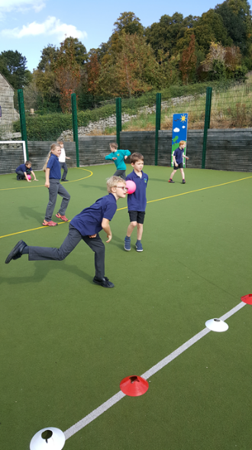
- increased confidence, knowledge and skills of all staff in teaching PE and sport
- broader experience of a range of sports and activities offered to all pupils
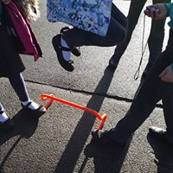
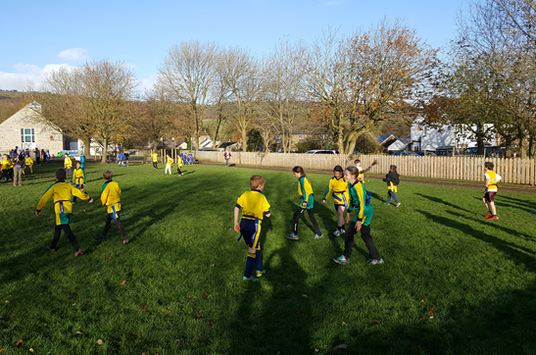
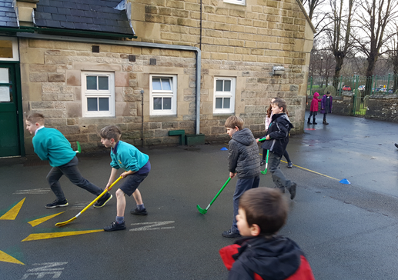
- increased participation in competitive sport

Support for review and reflection - considering the 5 key indicators from DfE, what development needs are a priority for your setting and your students now and why? Use the space below to reflect on previous spend, identify current need and priorities for the future.

Key achievements to date 2016 - 2017: | Areas for further improvement and baseline evidence of need for 2017 - 2018
Raising profile  -Increased social media profile  Increased confidence, knowledge and skills of all staff  -Team teaching with external coaches – football, cricket, basketball (8 teachers)  Engaging all pupils in regular physical activity  - Significant increase in participation of girls  -A range of extracurricular opportunities for all pupils led be sport coaches and staff  Broader experience of a range of sports and activities offered to all  - Skipping and circle skills day  - Bikeability  Increased participation in competitive sport  -Participation in all 15 Cluster Events  -Hired transport has enabled participation in 15 different inter-school sports events | -Increased lunchtime structured sports/physical activity clubs – external providers, midday supervisors and teacher-led  -Increase engagement of all pupils in regular physical activity in ‘lesson’ time  -PE lead role to be developed  -Improve sporting equipment for playground use  -Develop confidence, knowledge and skills of staff  -Develop Playground Sports Leader roles

Meeting national curriculum requirements for swimming and water safety | Please complete all of the below  (as of April 2018):
What percentage of your Year 6 pupils could swim competently, confidently and proficiently over a distance of at least 25 metres when they left your primary school at the end of last academic year (July 2017)? | 100%
What percentage of your Year 6 pupils could use a range of strokes effectively [for example, front crawl, backstroke and breaststroke] when they left your primary school at the end of last academic year (July 2017)? | 100%
What percentage of your Year 6 pupils could perform safe self-rescue in different water-based situations when they left your primary school at the end of last academic year (July 2017)? | 86%
What percentage of your current Year 6 cohort swim competently, confidently and proficiently over a distance of at least 25 metres? | 90%
What percentage of your current Year 6 cohort use a range of strokes effectively [for example, front crawl, backstroke and breaststroke]? | 80%
What percentage of your current Year 6 cohort perform safe self-rescue in different water-based situations? | 100%
Schools can choose to use the Primary PE and Sport Premium to provide additional provision for swimming but this must be for activity over and above the national curriculum requirements. Have you used it in this way? | Yes/No

Action Plan and Budget Tracking
Capture your intended annual spend against the 5 key indicators. Clarify the success criteria and evidence of impact that you intend to measure to evaluate for students today and for the future.

Academic Year: 2017/18 | Total fund allocated: £16,630 | Date Updated: January 2018
Key indicator 1: The engagement of all pupils in regular physical activity – Chief Medical Officer guidelines recommend that primary school children undertake at least 30 minutes of physical activity a day in school |  |  |  | Percentage of total allocation:
 |  |  |  | 24%
School focus with clarity on intended impact on pupils: | Actions to achieve: | Funding allocated: | Evidence and impact: | Sustainability and suggested next steps:
- Increase daily opportunities for involvement in organised games and activities at lunchtimes  - Increase opportunities for active learning across the broader curriculum  -Increase amount of extra-curricular activities/clubs  Develop regular opportunities for “Personal Best” by:  - PE lesson based activities  - Whole school activities  - Break and lunchtime independent activities  -Active engagement with National and International Sporting Events’, e.g. Sport Relief & Commonwealth Games 2018, World Cup 2018 | - secure sport coaches 3x per week to lead activities and support Sport Leaders  - provide training for Y5 and Y6 Sports Leaders  - purchase extra equipment  - ensure a range of activities across a week to allow all children to get motivated, enthused and involved  -ensure children have a minimum 15 minutes daily activity in ‘lesson’ time e.g. BBC Supervmovers to support maths, NHS Change4Life activities, the Daily Mile etc. Implement at PDM to discuss and action  -Liaise with MDSs to promote lunchtime activities  - arrange external coaches to lead extra-curricular activities 2x per week  - staff to lead weekly after school club  -Staff to include these activities in their lessons  -Playground activities to encourage ‘personal best’ opportunities  -Staff to include whole school physical activity challenges as part of the event | £3600  £180  £1000  N/A  N/A  N/A  £2400 cost to be absorbed by session charge of £3.50 for non-disadvantaged pupils  £200 contingency for after school club  As above | Evidence of number of pupil involved  Pupil feedback in questionnaires.  Feedback from Sport Leaders  Timetable ensures a range of activities  Staff observations and feedback  Number and regularity of events  Number of pupils involved  Number and regularity of events  Records of participation  Feedback from pupils  Feedback from teachers on children’s activity levels and attitude to activity and learning  Whole school activities relating to: e.g. National Fitness Day (Sept 2017), Sport Relief (Mar 2018), Commonwealth Games (Apr 2018) World Cup 2018 (Jun/Jul)
Key indicator 2: The profile of PE and sport being raised across the school as a tool for whole school improvement |  |  |  | Percentage of total allocation:
 |  |  |  | 14%
School focus with clarity on intended impact on pupils: | Actions to achieve: | Funding allocated: | Evidence and impact: | Sustainability and suggested next steps:
-Celebration ‘Shine’ assembly every week to ensure the whole school is aware of the importance of PE and Sport and to encourage all pupils to aspire to being involved in the assemblies.  -Pictures and details of events shared on social media  -Role models - local sporting personalities so pupils can identify with success and aspire to be a local sporting hero.  -Notice boards in main entrance to raise the profile of PE and Sport for all visitors and parents.  -Active engagement with National and International Sporting Events’, e.g. Sport Relief & Commonwealth Games 2018, World Cup 2018.  -Promote out of school physical activity and school sport opportunities  - Develop regular communication with Governance  -Work in partnership with SSP, local cluster schools, clubs and other sporting providers  -Apply for School Games Mark – BRONZE | - Achievements celebrated in assembly (match results and notable achievements in lessons, lunchtimes etc.)  -Regular updates  - Ascertain which local personalities the pupils relate to and invite them into school (Becky Lynne, Marcus Scotney)  -Create noticeboard with Sport Leader involvement  - Staff to include whole school physical activity challenges as part of the event  -PE Co-ordinator & Class Teachers to ensure proactive promotion of opportunities  -agenda item at Standards and Curriculum meeting. Inclusion in termly HT report  - Inclusion in all events  - Derbyshire School Sports Affiliation fee  -purchase SSP affiliation and sign up to website | N/A  £500 PE lead time  £1200  £560 | Pupils enjoy the celebration of sharing sporting achievements  Record on ‘Facebook’  Personalities to be invited into school for summer term  Events celebrated and shared  Events noted and celebrated as above  Flyers/posters distributed/shared  S and C meet termly  Partnerships in place  Application in summer term

Key indicator 3: Increased confidence, knowledge and skills of all staff in teaching PE and sport |  |  |  | Percentage of total allocation:
 |  |  |  | 35%
School focus with clarity on intended  impact on pupils: | Actions to achieve: | Funding  allocated: | Evidence and impact: | Sustainability and suggested  next steps:
-Raise standards in PE and Sport by developing teacher skills and confidence leading to good / outstanding teaching and learning | -Staff to team teach with specialist sports coaches  -Staff to complete an audit to baseline  -Plan to identify training needs and access training opportunities  -attend SSP training and termly meetings  - PE subject leader to meet with a broad range of pupils to talk about their PE lessons and to ascertain their knowledge and understanding of the subject. | £4800  N/A  N/A  PE lead time £500  £500 CPD | Staff audit of skills and confidence  Feedback from CPD  Feedback from pupils
Key indicator 4: Broader experience of a range of sports and activities offered to all pupils |  |  |  | Percentage of total allocation:
 |  |  |  | 48%
School focus with clarity on intended  impact on pupils: | Actions to achieve: | Funding  allocated: | Evidence and impact: | Sustainability and suggested  next steps:
-Continue to offer a wider range of activities both within and outside the curriculum in order to get more pupils involved.  - Focus particularly on those pupils who do not take up additional PE and Sport opportunities. | -Undertake all cluster activities offered through the cluster sports partnership Gold package  -pay for transport to cluster events  - secure sport coaches 3x per week to lead activities and support Sport Leaders  - provide training for Y5 and Y6 Sports Leaders  - purchase extra equipment  - ensure a range of activities across a week to allow all children to get motivated, enthused and involved | £1200  £2000  £3600  £180  £1000 | Records highlight range of activities
Key indicator 5: Increased participation in competitive sport |  |  |  | Percentage of total allocation:
 |  |  |  | 17%
School focus with clarity on intended  impact on pupils: | Actions to achieve: | Funding  allocated: | Evidence and impact: | Sustainability and suggested  next steps:
Increase opportunities for pupils to take part in inter school competitions | -ensure all children have the opportunity to take part in cluster events (15 events across the year) organized by Extra Time  - transport to events  - Derbyshire SSP affiliation | £1200  £2000  £560 | Records highlight opportunities for pupils

