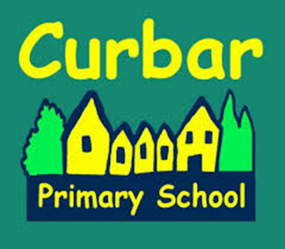

School Uniform
The school has a dress code, which we actively encourage the children to follow. It generates a feeling of belonging to the Curbar family and being part of a team. It also looks really smart! Polo shirts, sweat shirts, t-shirts and other items with the printed school logo are available. School uniform is ordered online at School Trends https://www.schooltrends.co.uk/

Boys
Trousers/shorts/socks |  | Grey
Shirt |  | Navy or White
Sweatshirt or jumper |  | Jade Green
Shoes |  | Black / Brown / Grey

Girls
Skirt/pinafore/trousers |  | Grey
Shirt |  | Navy or White
Summer dress |  | Green and White check / stripes
Socks/tights |  | Grey / White / Navy
Sweatshirt/cardigan |  | Jade Green
Shoes |  | Black / Brown / Grey

PE Kit for all children
T-shirt |  | Jade Green or White
Shorts |  | Black / Navy
Plimsolls |  | Black (elasticated for infants)
Slipper bag |  | Any colour

Hoodie Blue (please note hoodies are for PE only)

