All About Me

I’m starting school!

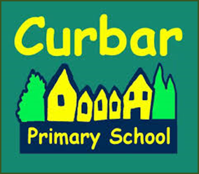

Dear parents
Here at Curbar Primary School we place great importance on learning about our pupils before they start school. We aim to achieve this through regular transition visits before September and good communication with parents.
Please share this booklet with your child and take time to complete it together. Your child can stick in photos, draw pictures or write – you decide! Please bring the completed booklet back to school during the first week.
We look forward to meeting you and your child again during our transition days and in September. Thank you for your cooperation and support.
Kind regards

The Reception and Key Stage 1 team

My name is

My photograph

This is me.

This is my house.

This is my family

This is my friend

My friend is called

Three things I like doing at home

Three things I am looking forward to doing at school

Three things I am unsure about doing at school

Getting Ready for School
Starting school is an exciting time. There are many ways in which you can work with your child in order to ensure a successful transition:
- Sing and learn nursery rhymes and number songs
- Recite number names to 10 and beyond
- Count small sets of objects e.g. toys cars in a garage etc.
- Play I Spy and thinking about the first sound in words
- Generate string of rhyming words e.g. cat, sat, mat etc.
- Share books and listen to stories
To help your child become more independent, please help them learn how to:
- Get dressed and undressed independently
- Put on a coat and fasten it up without adult help
- Put on shoes
- Use cutlery independently
- Go to the toilet and wash hands without adult support
And finally for the adults! Please provide a little ‘pen portrait’ below of how you would describe your child e.g. chatty, shy, confident, likes the outdoors, left or right handed etc. There is no right or wrong – it provides us with useful information that can help us to settle your child into reception.

