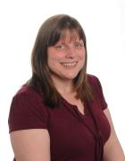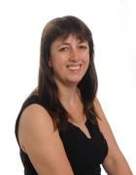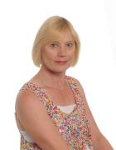

**Staff at Curbar Primary School 2018 - 19**

Mr Beahan is the Head teacher. He also teaches for some of the week. He is the designated safeguarding lead in school.

Miss Pattison teaches children in Years 3 and 4 (Class 2 – Silver Birch). She is the deputy designated safeguarding lead in school.

Miss Gregory teaches the children in Years 5 and 6 (Class 3 - Elder).

Mrs Berry will be your first teacher. She is also the Senior Teacher and teaches Class 1 (Busy Bees). She is the school SENCo.

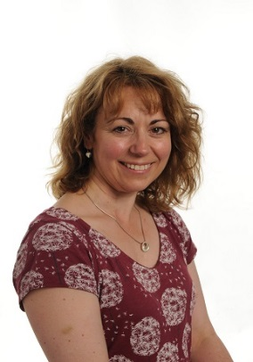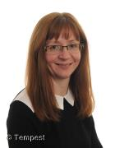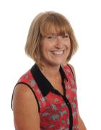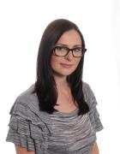

Mrs Sargen is a teaching assistant in the Beehive and is a playground supervisor at lunchtime.

Mrs Ridgeway is a teaching assistant and is a playground supervisor at lunchtime.

Mrs Patterson is a teaching assistant and she will work with you in the classroom.

Mrs Rumney works in the school office.

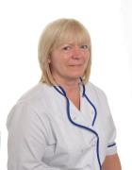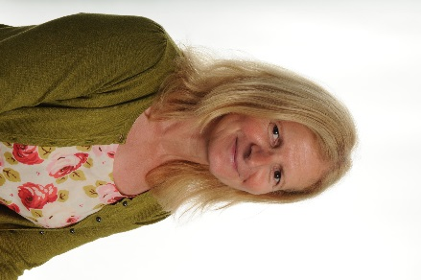

Mrs Allen is a volunteer and is a playground supervisor at lunchtime.

Mrs Cain is a midday supervisor and will help you at lunchtime.

Mrs Wilson is the cook and cleaner. She keeps school clean and makes yummy dinners.