Monday 16 July 2018
Dear Parents and Carers

I can’t quite believe the summer break is almost upon us. Once again, we have achieved many wonderful things both as a school and as a community. I would like to thank everyone for their support which has led to another successful year. Firstly, all the teaching and support staff who work hard to provide the children with a good education. Also, to the school governors who skilfully support the school and give up their time freely. A big thanks also to the PTFA who give a huge amount of time and effort to organise events which raises money to benefit our children. And thanks to the parents/adults who support both the children and school in trying to ensure our pupils reach their potential. Finally, thanks to the children who never cease to impress me with their kindness, enthusiasm and determination to make the school the very special place it is. I look forward to these partnerships continuing in September and beyond. School closes on Friday 20 July 2018 at 3:10pm and reopens to children on Tuesday 4 September 2018 at 8.50am. I wish you all a safe and happy holiday.

What a week!
Last week was a very busy and exciting week in school and typifies all the fantastic things that go on at Curbar. We had four Y6s (Farrah, Oliver, Poppy and Ines) do themselves proud at the LMS cluster literacy quiz. The whole school took part in two performances of ‘Oink’ at the Village Hall to great critical acclaim. Our annual sports day took place at Calver Cricket Ground and despite early rain was a great success. And the week was rounded off by the rain interrupted Curbar PTFA BBQ at School House – but it didn’t dampen spirits. Thanks to all those who in some way supported these wonderful school community events.

Class 1 visit to the Blue Planet
Please be reminded that class 1 need to be in school by 7:50am to go on their visit to the Blue Planet Aquarium on Tuesday 17 July 2018. They aim to return to school at approximately 4:00pm.

Y6 Leavers
Goodbye, Au Revoir, Arrivederci…although they have a week left, we wish our year 6s lots of happiness and success in the future as they embark on the next stage of their lives. They have done the school proud this year and they have given, and I am sure they will take away, many happy memories. I hope they will also take away the values that they have developed at Curbar and continue to build on their academic success.
‘Set your sights on high; Let no one steal your dreams; Your only limit is the sky.’
Parents/family of year 6 children are invited to attend the ‘Leavers Assembly’ on Thursday 19 July at 9:15am.

Staffing Update
We are also saying goodbye to Mrs Rumney at the end of this term. Mrs Rumney has been a wonderful asset to the school since she arrived seven years ago and will be greatly missed. You are welcome to make any donations for a leaving gift. Mrs Rumney will be working at Dronfield Infant School from September and we wish her lots of luck and happiness. We will let you know when we have made our new School Business Officer appointment.

Final day arrangements and closing for summer
We are closing for the summer holiday on Friday 20 July. We are asking that all children are collected at 3:10pm so that we can give our leaving year 6s a whole school guard of honour. If you are unable to collect a key stage 2 child at this time, then please inform school.
Children are also invited to attend school in non-uniform and bring in (non-electronic) games to enjoy on Friday afternoon.
End of year school reports and parents evening
You should have received your child’s end of year report. Please return the slip with any comments. Please inform the school office if you did not receive the report. There will be an opportunity to discuss these further and view books by ‘dropping in’ to an optional parents evening on Monday 16 July from 3.30 - 5.15pm (Class 1 and 2) and on Tuesday 17 July from 3:30 – 5:15pm (Class 3 only) . No appointment is necessary.

SATs success!
We recently received our end of key stage 2 SATs results of which we are, again, extremely proud. A summary can be found below:

Subject | Percentage of pupils achieving the expected standard: school | Percentage of pupils achieving the expected standard: nationally (2018) | Average scaled score: school | Average scaled score: nationally
English reading | 100% | 75% | 111 | 105
English grammar, punctuation and spelling | 90% | 78% | 110 | 106
Mathematics | 90% | 76% | 107 | 104
English writing (teacher assessment) | 90% | 78% | N/A | N/A
Science (teacher assessment) | 100% | 82%  (2017 data) | N/A | N/A

Congratulations to the year 6 children and staff on their hard work and well deserved success.
Term dates for 2018/19
Please find attached the term dates (including whole school closure days for staff training apart from one yet to be decided) for next year. A diary for the autumn term will be issued on our return to school.

Rewards and Badge Amnesty
For good behaviour, the children have been receiving bronze, silver and gold badges throughout the year. We will be celebrating all of our award winners in school this week. All those children who have achieved ‘Gold’ will be put into a raffle draw for some prizes (book vouchers) to be drawn at the end of this week! However, with the year coming to a close, we are asking that the children return their badges to their class teacher so they can start again in September.

House Winners
This year’s House Winners are Spring. As a reward, they will spend part of the morning of Wednesday 18 July at the lower field at Cliff College enjoying games and an ice lolly with their house mates.

Lost property
For such a small school we seem to generate a huge amount of ‘lost’ property! As a result, we are going to put the items ‘on display’ (weather permitting) at the end of the school day on Monday 16 and Tuesday 17 July. Any items that are not claimed will be recycled.

School Dinners
School dinners will cost £2:10 from the start of the new academic year. School dinners are free to those children who are in KS1 and those in receipt of Free School meals. Please note that these can be paid for on Parent Pay.
Citizenship of the Term Assembly
Our assembly is set to take place on Friday 20 July at 9:10am. You should have been texted if your child is a recipient of this award – as voted for by their classmates - and you are welcome to join us for the award assembly.
Little Echoes

There are a few Little Echoes books available for sale from the school office, these are priced at £3.50 each.

Lunchtime Volunteers/Relief work
We are once again requesting volunteers to help with lunchtime supervision on the playground so school staff can take children to use the MUGA and pergola more regularly. Alternatively, a more formal arrangement can be made and we are happy to pay for lunchtime relief work (working on a ‘when you can’ basis). Please let the school office know if you are interested.

Parental Questionnaire
We would appreciate you taking the time to fill this in as we always value your thoughts and the school is always looking at ways of improving. If you complete the form and feel strongly about a particular aspect of the questionnaire, please feel free to arrange an appointment to discuss this further. Parents and carers can give their views of our school at any time of the school year using an online questionnaire called Parent View on which you will find the same 12 questions. You can register with an email address and a password at https://parentview.ofsted.gov.uk. Once your login has been activated, it only takes a few minutes to complete. Please return the questionnaire to school by Friday 20 July.

Pupil Survey Results – June 2018
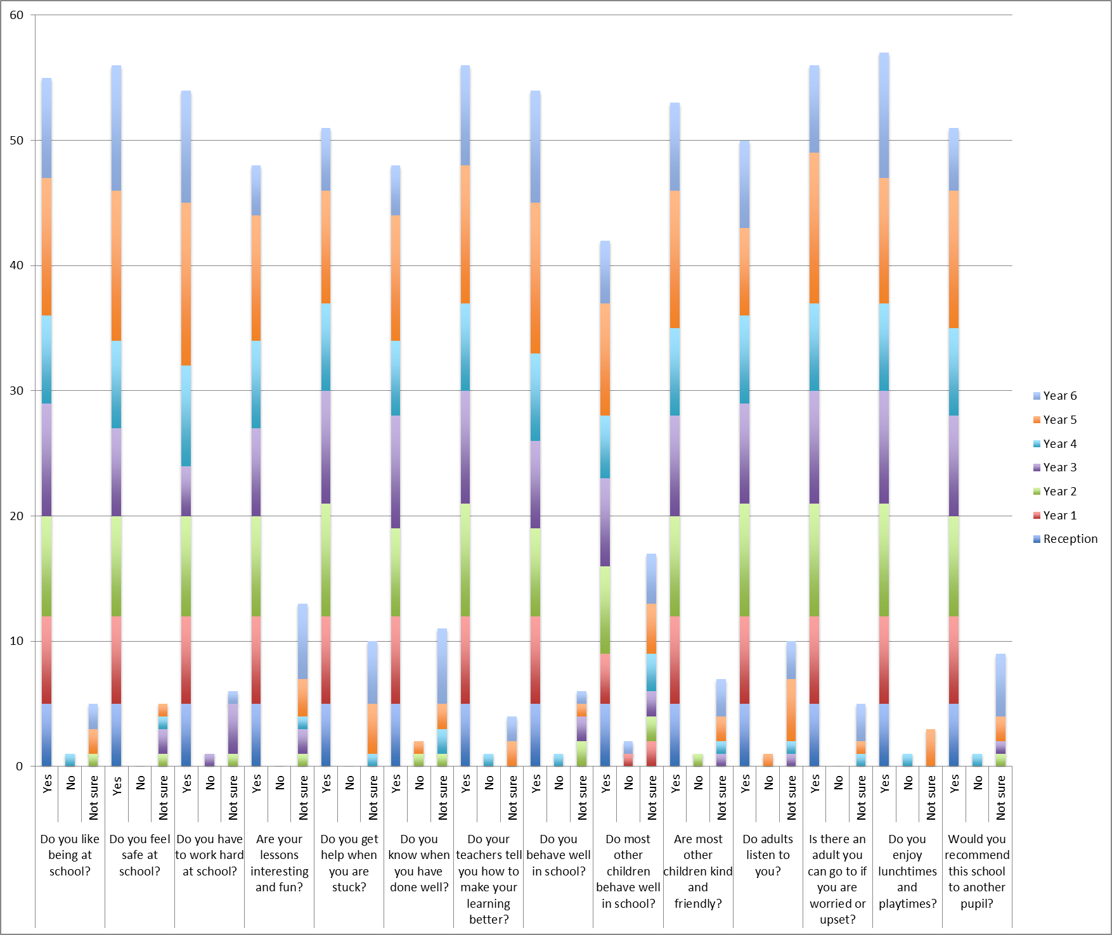

Help – donations required!
We are looking for some good quality second hand toys, games, puzzles and jigsaws for our nurture group. Please donate to the school office. Thank you.

Swimming
Please contact Miss Gregory if you are able to help out with KS2 swimming sessions next year. They will take place on Tuesday afternoons from 2 – 3:30pm.

Out of Hours and Summer Safeguarding – Advice for Parents
Most of us look forward to the summer break with great excitement but for some young people it can be a time of anxiety especially for those who rely on regular face-to-face contacts with their friends or who enjoy the security and structure provided by the school day.

If you are concerned about any young person in respect of their emotional wellbeing or you feel that they are vulnerable to harm or abuse and you are uncertain whether they are receiving support you may wish to contact one of the agencies listed. Many of the agencies have established links and will ensure that your concern or query is directed to the appropriate agency.

- Call Derbyshire (Derbyshire County Council Social Services) 01629 593 193
- Child Line 0800 1111
- Online issues or exploitation contact Child Exploitation and Online Protection Agency (CEOP) https://www.ceop.police.uk/Ceop-Report/
- Suspicion that a young person is at risk of Child Sexual Exploitation- contact Safe and Sound 01332 362120
- Advice, support and options if you, or someone you love, goes missing or runs away- 24 Hour Anonymous Helpline Text or Call 116 000
- Radicalisation/Extremist behaviour see advice on: http://www.derbyshire.police.uk/Safety-advice/Terrorism/Prevent-Team/Prevent-Team.aspx
- Or contact:Police 101 (999 in an emergency)
- Crimestoppers UK 0800 555 111

The relaxed atmosphere of a summer break can also lead to young people lowering their guard. Please continue to talk to the young people in your care about online and social media safety and encourage them to share any concerns that they have about any contacts they receive. CEOP have an excellent website called “Think u know” which can be accessed on https://www.thinkuknow.co.uk/parents/ On the website there is a “Support Tools section on the top menu from which you can access a number of informative films which you may wish to watch on your own or with young people in your care.

Kind regards

Mr Simon Beahan, Headteacher

Curbar Primary School Terms and Holidays 2018/19
Half Term 1 (40 days)
Monday 3 September 2018 | Whole School Training Day – School Closed to pupils
Tuesday 4 September 2018 | Start of Autumn Term 1 – School Open to pupils
Friday 26 October 2018 | End of half term
Half Term Holiday – Monday 29 October 2018 – Monday 5 November 2018
Half Term 2 (35 days)
Monday 5 November 2018 | Whole School Training Day – School Closed to pupils
Tuesday 6 November 2018 | Start of Autumn Term 2 – School Open to pupils
Friday 21 December 2018 | End of term
Christmas Holiday – Monday 24 December 2018 – Friday 4 January 2019
Half Term 3 (30 days)
Monday 7 January 2019 | Start of Spring Term 1 – School Open to pupils
Friday 15 February 2019 | End of half term
Half Term Holiday – Monday 18 February 2019 – Friday 22 February 2019
Half Term 4 (35 days)
Monday 25 February 2019 | Start of Spring Term 2 – School Open to pupils
Friday 12 April 2019 | End of term
Easter Holiday – Monday 15 April 2019 - Friday 26 April 2019
Half Term 5 (19 days)
Monday 29 April 2019 | Start of Summer Term 1 – School Open to pupils
Monday 6 May 2019 | School Closed (May Day Bank Holiday)
Friday 24 May 2019 | End of half term
Half Term Holiday – Monday 27 May 2019 – Monday 3 June 2019
Half Term 6 (36 days)
Monday 3 June 2019 | Whole School Training Day – School Closed to pupils
Tuesday 4 June 2019 | Start of Summer Term 2 – School Open to pupils
Friday 19 July 2019 | End of term
Monday 22 July 2019 | Whole School Training Day – School Closed to pupils

Please note that we are awaiting to confirm one other Whole School Closure Day (INSET) for 2018/19

