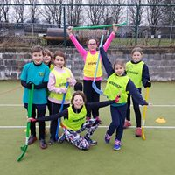
CURBAR PRIMARY SCHOOL

EVIDENCING THE IMAPCT OF PRIMARY PE AND SPORT PREMIUM FUNDING – JULY 2019

Schools must use the funding to make additional and sustainable improvements to the quality of PE and sport they offer. This means that you should use the Primary PE and Sport Premium to:

- develop or add to the PE and sport activities that your school already offers
- build capacity and capability within the school to ensure that improvements made now will benefit pupils joining the school in future years
There are 5 key indicators that schools should expect to see improvement across:
- the engagement of all pupils in regular physical activity - the Chief Medical Officer guidelines recommend that all children and young people aged 5 to 18 engage in at least 60 minutes of physical activity a day, of which 30 minutes should be in school
- the profile of PE and sport is raised across the school as a tool for whole-school improvement
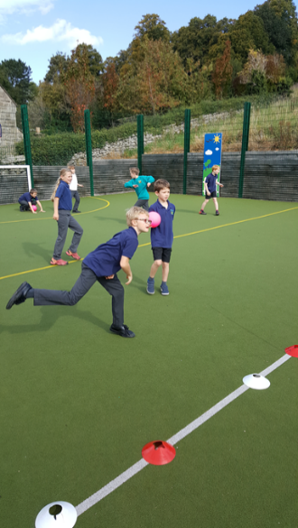
- increased confidence, knowledge and skills of all staff in teaching PE and sport
- broader experience of a range of sports and activities offered to all pupils
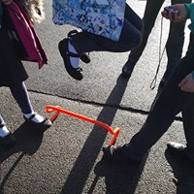
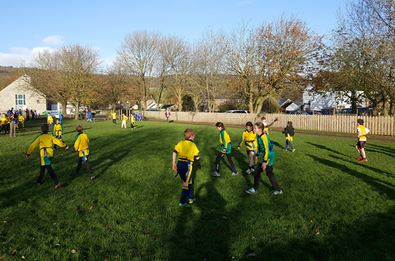
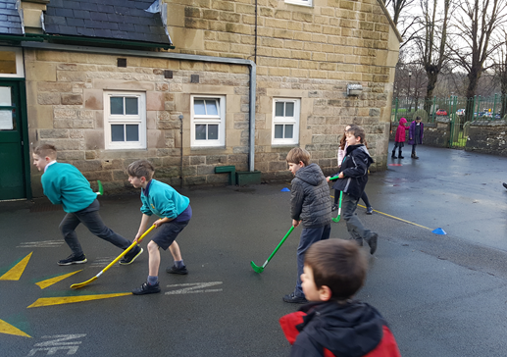
- increased participation in competitive sport

Support for review and reflection - considering the 5 key indicators from DfE, what development needs are a priority for your setting and your students now and why? Use the space below to reflect on previous spend, identify current need and priorities for the future.

Key achievements to date 2017 - 2018: | Areas for further improvement and baseline evidence of need for 2018 - 2019
- Y3/4 participated in Five 60 to encourage an active, healthy lifestyle and increase children's knowledge of the benefits of healthy eating and exercise through curriculum based practical sessions.  - Increased social media profile and acknowledgement of importance of PE/Sport in a broad and balanced curriculum.  - Increased confidence, knowledge and skills of all staff through team teaching with external coaches across the year.  - Engaging all pupils in increased physical activity across the curriculum.  - Pupils engaged in a range of extracurricular opportunities led by sport coaches and staff e.g. dodgeball, archery, gardening…  - Increased participation in competitive sport for all pupils with inter school festivals and competitions within the 16 Cluster sport events and Rural Derbyshire Partnership events.  - Training of Sports Leaders to lead lunchtime sporting events for all pupil.  - Significant investment in playtime/sporting resources to support more healthy and active lunchtimes. | - Increase engagement of all pupils in regular physical activity in ‘lesson’ time.  - PE lead role to be developed.  - Sustain quality of equipment for playground use and sporting use (incl. markings)  - Develop confidence, knowledge and skills of staff further with support of external sports coaches to impact on the quality of teaching and learning.  - To develop the children’s leadership skills for sport and physical activity  - Apply and gain the Derbyshire Healthy School Award.  - To use the medium of PE/Sport to help develop a school vision.  - Improve quality/raise profile of ‘Sports Day’.  - To develop outdoor learning including Forest School for reception children.  - For Sport and PE to be used as a tool for developing the mental, physical and SMC development for all children and for whole school improvement

Meeting national curriculum requirements for swimming and water safety | Please complete all of the below  (as of July 2019):
What percentage of your Year 6 pupils could swim competently, confidently and proficiently over a distance of at least 25 metres when they left your primary school at the end of last academic year (July 2018)? | 100%
What percentage of your Year 6 pupils could use a range of strokes effectively [for example, front crawl, backstroke and breaststroke] when they left your primary school at the end of last academic year (July 2018)? | 90%
What percentage of your Year 6 pupils could perform safe self-rescue in different water-based situations when they left your primary school at the end of last academic year (July 2018)? | 100%
What percentage of your current Year 6 cohort swim competently, confidently and proficiently over a distance of at least 25 metres? | 92%
What percentage of your current Year 6 cohort use a range of strokes effectively [for example, front crawl, backstroke and breaststroke]? | 85%
What percentage of your current Year 6 cohort perform safe self-rescue in different water-based situations? | 100%
Schools can choose to use the Primary PE and Sport Premium to provide additional provision for swimming but this must be for activity over and above the national curriculum requirements. Have you used it in this way? | Yes/No (for one pupil)

Action Plan and Budget Tracking
Capture your intended annual spend against the 5 key indicators. Clarify the success criteria and evidence of impact that you intend to measure to evaluate for students today and for the future.

Academic Year: 2018/19 | Total fund allocated: £16,650 | Date Updated: July 2019
Key indicator 1: The engagement of all pupils in regular physical activity – Chief Medical Officer guidelines recommend that primary school children undertake at least 30 minutes of physical activity a day in school |  |  |  | Percentage of total allocation:
 |  |  |  | 24%
School focus with clarity on intended impact on pupils: | Actions to achieve: | Funding allocated: | Evidence and impact: | Sustainability and suggested next steps:
For staff and pupils to work towards a minimum of 30 minutes of physical activity a day through various activities during curriculum, lunch times and extra-curricular activities. | - secure sport coaches 3x per week to lead activities and support Sport Leaders  - provide training for Y5 and Y6 Sports Leaders/Reception buddies  - purchase extra equipment  - ensure a range of activities across a week to allow all children to get motivated, enthused and involved  -ensure children have a minimum 15 minutes daily activity in ‘lesson’ time e.g. BBC Supervmovers to support maths, NHS Change4Life activities, the Daily Mile etc. Implement at PDM to discuss and action  - purchase ‘Maths of the Day’ and accompanying staff training to ensure activity in lesson time  - arrange external coaches to lead extra-curricular activities 2x per week  - staff to lead weekly after school club each half term | £3120  £200  £200  Cost neutral  Cost neutral  £545  Cost of coaches absorbed by session charge of £3.50 for non-disadvantaged pupils | Evidence of number of pupil involved  Pupil feedback in questionnaires.  Feedback from Sport Leaders  Timetable ensures a range of activities  Staff observations and feedback  Display of active learning across school  Number and regularity of events  Number of pupils involved  Number and regularity of events | Continue to work with staff and pupils so they have knowledge of the different ways they can be active during the school day.  Plan for training for existing and new activities each academic year.
Key indicator 2: The profile of PE and sport being raised across the school as a tool for whole school improvement |  |  |  | Percentage of total allocation:
 |  |  |  | 11%
School focus with clarity on intended impact on pupils: | Actions to achieve: | Funding allocated: | Evidence and impact: | Sustainability and suggested next steps:
For Sport and PE to be used as a tool for developing the mental, physical and SMC development  To develop outdoor learning in other areas of the curriculum (particularly maths)  To continue to maintain the high profile of PE in school amongst pupils, staff, parents, governors and the wider community.  For the values and achievements learnt and achieved to feed into the rest of the school curriculum and school life. | -Celebration ‘Shine’ assembly every week to ensure the whole school is aware of the importance of PE and Sport and to encourage all pupils to aspire to being involved in the assemblies  -Pictures and details of events shared on social media  - Notice boards in main entrance to raise the profile of PE and Sport for all visitors and parents  - Develop regular communication with Governance; inclusion in termly HT report  - Apply for School Games Mark – BRONZE  - Develop a whole school vision with an ethos that supports the role of sport for whole school improvement  - Reception pupils to access weekly Forest School (outdoor learning) following training of HLTA  - publicize roll of sport/PE/outdoor learning in local newspapers as a means of advertising qualities of the school  -Playground markings to make area fit for purpose  -Apply for Derbyshire Healthy School Award | Cost neutral  Cost neutral  Cost neutral  Cost neutral  Cost neutral  Cost neutral  £1000  Cost neutral  £500  Cost neutral | The profile of sport is high across the school and is evident in reports, presentations, websites, displays etc.  School values are developed through PE and sport and are evident around school.  Pupil interviews, School Council and Sport Ambassador meetings will provide further evidence during discussions.  All children are learning how to look after their mental health.  Pupil questionnaires and meetings | Continue with reports and presentations about sport to the whole school.  Continue to promote physical activity through celebrating achievements and inviting visitors into school who can promote this.  Develop reporting skills to a wider audience such as the local community.  Roll out Forest School provision to Y1 (this year’s reception)  Use the DHSA audit information to continue to support pupil/staff well-being.

Key indicator 3: Increased confidence, knowledge and skills of all staff in teaching PE and sport |  |  |  | Percentage of total allocation:
 |  |  |  | 45%
School focus with clarity on intended  impact on pupils: | Actions to achieve: | Funding  allocated: | Evidence and impact: | Sustainability and suggested  next steps:
Raise standards in PE and Sport by developing teacher skills and confidence leading to at least good teaching and learning | -Staff to team teach with specialist sports coaches  -Plan to identify training needs and access training opportunities  -attend SSP training and termly meetings  PE subject leader to meet with a broad range of pupils to talk about their PE lessons and to ascertain their knowledge and understanding of the subject. | £7000  Cost neutral  Part of annual subscription  PE lead time £500 | -Staff audit of skills and confidence  -Pupils are being taught high quality PE lessons. (observations)  -Pupils have access to a wide range of activities.  Feedback from CPD  Feedback from pupils | Staff are developing higher level skills to deliver quality PE lessons and activities.  CPD for staff will provide improved teaching of PE for following years.  Continued CPD and training will be required for new and existing activities each year.
Key indicator 4: Broader experience of a range of sports and activities offered to all pupils |  |  |  | Percentage of total allocation:
 |  |  |  | 1%
School focus with clarity on intended  impact on pupils: | Actions to achieve: | Funding  allocated: | Evidence and impact: | Sustainability and suggested  next steps:
-Continue to offer a wider range of activities both within and outside the curriculum in order to get more pupils involved.  - Focus particularly on those pupils who do not take up additional PE and Sport opportunities. | -Undertake all cluster activities offered through the cluster sports partnership Gold package  -pay for transport to cluster events  - secure sport coaches 3x per week to lead activities and support Sport Leaders  - provide training for Y5 and Y6 Sports Leaders  - purchase extra equipment  - ensure a range of activities across a week to allow all children to get motivated, enthused and involved  -pay for Pupil Premium children to access weekly multi skills after school club  -Bikeability/Balancability  -Links with external providers e.g. Calver Cricket Club, Bakewell Mannerians RFC.  -free sport kit obtained through Nike/premier league | See KP5  See KP5  See KP1  See KP1  See KP1  £200  Cost neutral -RDSSP subscription  Cost neutral | Pupils are developing skills in a wide range of exciting new sports and activities. This is evident in lessons, competitions entered, and activities children are trying outside of school (because of activities delivered at school.)  Are all the children inspired to try new sports and/or develop their interests in their current sports?  Do the children see that sport can be used for a vehicle for many things including mental wellbeing, fun, team spirit etc?  Pupil feedback | New activities introduced continue to be part of PE lessons.  Continue to provide children with training for a broad range of physical activities.
Key indicator 5: Increased participation in competitive sport |  |  |  | Percentage of total allocation:
 |  |  |  | 24%
School focus with clarity on intended  impact on pupils: | Actions to achieve: | Funding  allocated: | Evidence and impact: | Sustainability and suggested  next steps:
All groups of children involved in intra school or inter school competitions and skills festivals.  For the children to demonstrate the school values during competition.  To show determination and understand how to cope with both winning and losing.  Individual and team success during competition. | - Affiliation to Rural Derbyshire SSP school partnership. Access to L2 School Games finals and County finals (£600) 2019/20 Paid July 2019  -Taking part in cluster competitions, festivals and events for SEND children (Extra Time Coaching £1200)  -Transport to events as rural area and events, facilities and competitions are not in the same village  -Swimming Gala  -Sports Day at local cricket Club | £560  £1200  £2148  £20  Cost neutral | All groups of children involved in intra school or inter school competitions and skills festivals.  Children enjoy the activities and demonstrate school values when taking part in competition. (Discussions with children)  Team and individual success at events with some teams getting through to the next rounds.  Children taking part in competition out of school.  Children making links with external providers. | To continue to provide opportunities for as many of the children as possible to take part in competition during the school year.  Extra Time Coach to monitor the children and cohorts who are taking part in events (including gender groups, SEN and Pupil Premium children).
Total planned spend: £17, 082.50 (including £520 CF from 2017 – 18)

Actual Spend: £16, 082.50

Some actions to be carried forward to 2019 – 20 including £500 for CPD, £500 for playground markings…

